**NaPDI Repository Experiment Report**

**In Vitro Transport Induction Experiment(s)**

**Please fill in all relevant fields to the experiment(s) performed.**

1. **General Information**

|  |  |
| --- | --- |
| **Title of experiment** |  |
| **Research organization** |  |
| **Research organization’s overall effect cutoff** |  |
| **Precipitant name (therapeutic class)** |  |
| **Test system (please see appendix for options)** |  |

|  |  |  |  |  |
| --- | --- | --- | --- | --- |
| **Experiment number and title** | **Precipitant concentration (µM or µg/mL preferred)** | **Transporters involved** | **Induction measurement level (select one)** | **Number of experiments conducted** |
| **1.** |  |  | mRNA expression  protein expression  enzyme activity |  |
| **2.** |  |  | mRNA expression  protein expression  enzyme activity |  |
| **3.** |  |  | mRNA expression  protein expression  enzyme activity |  |

(Add more rows if needed. If multiple induction measurement types are measured, enter each separately)

|  |  |
| --- | --- |
| **Additional information (e.g. please describe if precipitant is an extract or fraction of a natural product, etc.)** |  |

**An example of data entered in the repository on the admin side:**

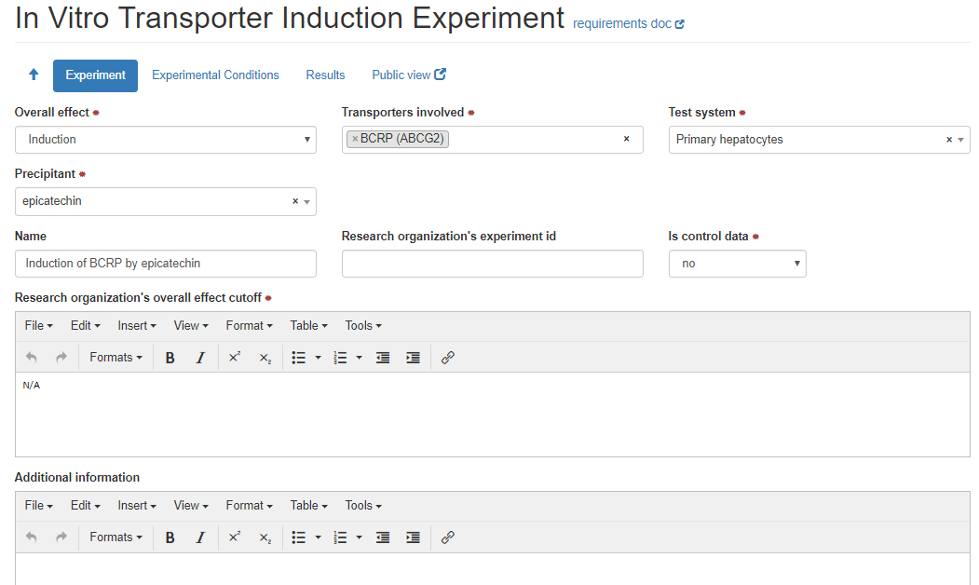

1. **Experimental Conditions**

|  |  |
| --- | --- |
| **Cell density** |  |
| **Test system lot number (manufacturer)** |  |
| **Cell viability test conducted?** | ☐ Yes  ☐ No |
| **Number of liver donors** |  |
| **Precipitant concentrations tested (µM units preferred)** |  |
| **Precipitant source** |  |
| **For mRNA determination:**  **Incubation Time (h units preferred)** |  |
| **mRNA determination method (i.e. qRT-PCR, etc.):** |  |
| **For protein determination:**  **Incubation Time (h units preferred)** |  |
| **Protein determination method (i.e. western blot, etc.):** |  |
| **For activity measurement:**  **Incubation Time (h units preferred)** |  |
| **Method for enzyme activity determination** | Rhodamine 123 uptake/retention assay  Other, specify: |

**Additional information regarding experimental conditions:**

|  |  |
| --- | --- |
| **Additional Information** |  |
| **Control conditions** |  |

**An example of data entered in the repository on the admin side:**

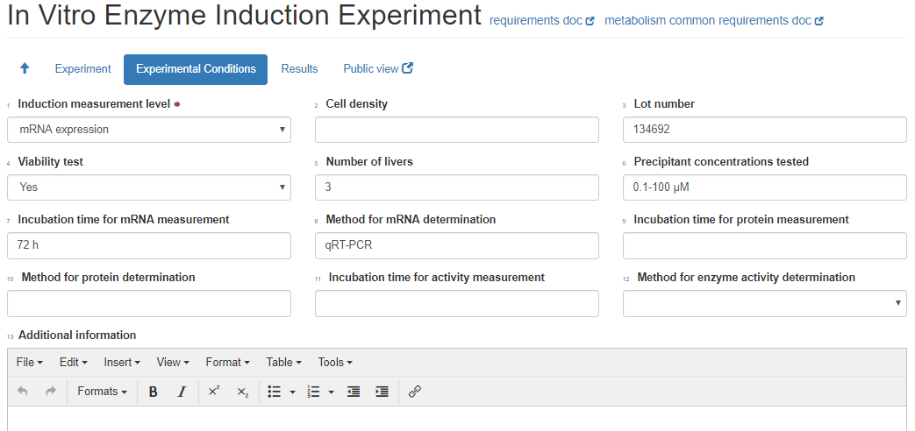

**3. Brief Summary of Results**

**For each experiment, please provide a brief summary of the results and conclusions**

|  |  |  |  |
| --- | --- | --- | --- |
| **Experiment number and title** | **Overall effect** | **Experiment type** | **Results values and types**  **(see appendix II and III for list of parameters and value types)** |
|  | Induction  Non-induction  Down Regulation | Control  Test |  |
|  | Induction  Non-induction  Down Regulation | Control  Test |  |
|  | Induction  Non-induction  Down Regulation | Control  Test |  |

(Add more rows if needed)

|  |  |
| --- | --- |
| Additional Information |  |
| Conclusion |  |

**Attach relevant figures and tables of results when submitting this form.**

**Appendix: Transport Test Systems**

* **Transfected/injected/siRNA knock-out cells**
* MDCK-transfected cells
* LLC-PK1-transfected cells
* HEK293-transfected
* HeLa-transfected
* CHO-transfected
* HepG2-transfected
* siRNA knock-out hepatocytes
* siRNA knock-out Caco-2 cells
* siRNA knock-out other cells
* X.laevis Oocytes-injected
* Inside-out membrane vesicles
* **Cell types**
* Hepatocytes
* Primary hepatocytes
* Cryopreserved hepatocytes
* Sandwich cultured hepatocytes
* Intestinal epithelial cells
* Caco-2 cells
* Other cells

**Appendix II: Transport Induction Parameters**

|  |  |  |
| --- | --- | --- |
| **Parameters** | **Preferred unit** | **Note** |
| **EC50** | µM |  |
| **Emax** | -fold |  |
| **% Increase in efflux compared with vehicle control** | % | P value can be added as needed. |
| **% Increase in efflux compared with positive control** | % | P value can be added as needed. |
| **% Decrease in accumulation compared with vehicle control** | % | P value can be added as needed. |
| **% Decrease in accumulation compared with positive control** | % | P value can be added as needed. |
| **% Decrease compared with vehicle control** | % | P value can be added as needed. |
| **% Decrease compared with positive control** | % | P value can be added as needed. |

**Appendix II: List of value types**

* Mean
* Mean ± SD
* Mean ± SEM
* Mean (range)
* Mean (CV%)
* Mean (CI)
* Median
* Median (CV%)
* Median (range)
* Median (CI)